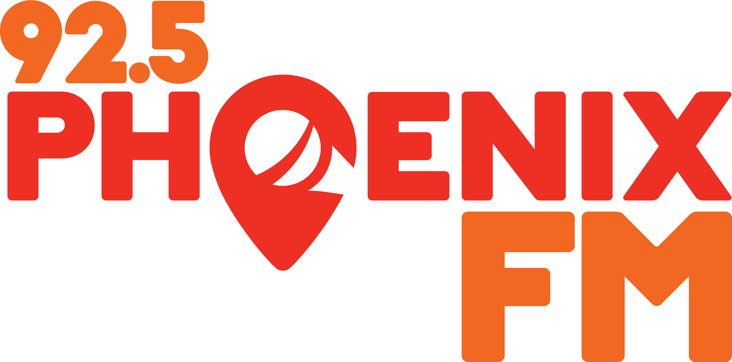
Programme Proposal

Name
Address
Ph. No
Email

- Have you attended a 92.5 Phoenix FM induction? Yes/No
- Have you received any broadcast training? Yes/No ‭

If yes, please specify what type of training:

Proposed Programme Title
(May be working title)

Frequency and Duration
(eg. (i) Half hour; hour; two-hour; (ii) Daily, weekly)
(i) | (ii)

Programme Category
(Talk, Music, Magazine etc.) If music, state genre

Community
How does the proposed progamme fit into 92.5 Phoenix FM’s commitment to the Dublin 15 community? Please see our Community Radio Ethos on www.phoenixfm.ie

Synopsis of the programme
Please explain your programme in one or two short paragraphs.

Proposed Running Order
A running order for the first progamme must be submitted as an attachment with this form.
Programme Team
Give details of any other personnel who will be taking part and their relevant position within the programme team.
(Include Presenters, Researchers, Technicians etc.)

Thank you for applying to make a programme with 92.5 Phoenix FM.
If you have any question, please don’t hesitate to ask for assistance.
Please submit the completed form to:
lynnsimpson925@gmail.com

DATE:

